**Week 4**

**Vinayak Prasad**

**3D Section**

**Batch D4**

1. select customername , count(distinct(ba.branch_name)) from Depositer d,BankAccount ba,branch b

where d.Accno =ba.Accno AND ba.branch_name=b.branch_name and branchcity = 'Delhi'

group by customername

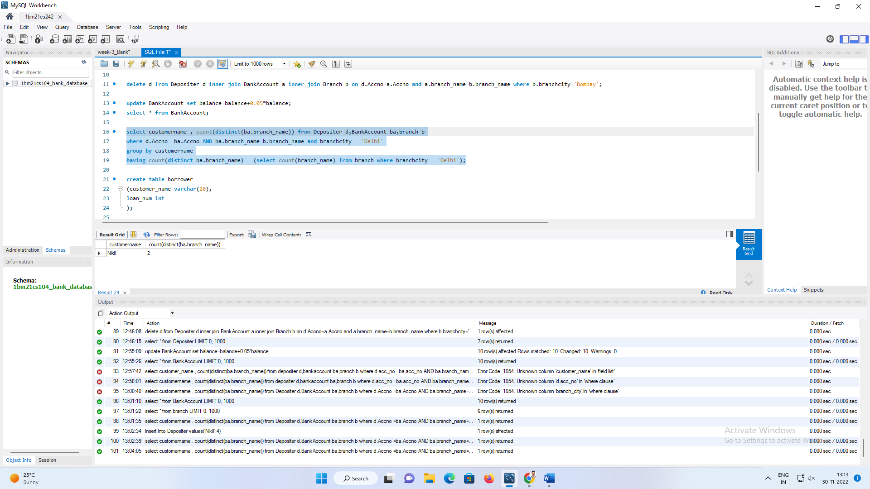having count(distinct ba.branch_name) = (select count(branch_name) from branch where branchcity = 'Delhi');

1. create table borrower  
   (customer_name varchar(20),  
   loan_num int  
   primary key(  
   );  
     
   insert into Borrower values('Avinash',1);  
   insert into Borrower values('Dinesh',2);  
   insert into Borrower values('Mohan',3);  
   insert into Borrower values('Nikil',4);  
   insert into Borrower values('Ravi',5);

select distinct d.customer_name  
from depositer d  
where d.customer_name in(  
select d.customer_name  
from branch b,Depositer d,BankAccount ba  
where b.branch_city='bangalore'and b.branch_name=ba.branch_name  
and ba.Accno=d.Accno and customer_name IN(select customer_name from borrower));



1. select  customer_name  
    from borrower  
   where customer_name not in(select customer_name from Depositer);

4. insert into branch values('SBI_CGRoad','Ahmedabad',70000);

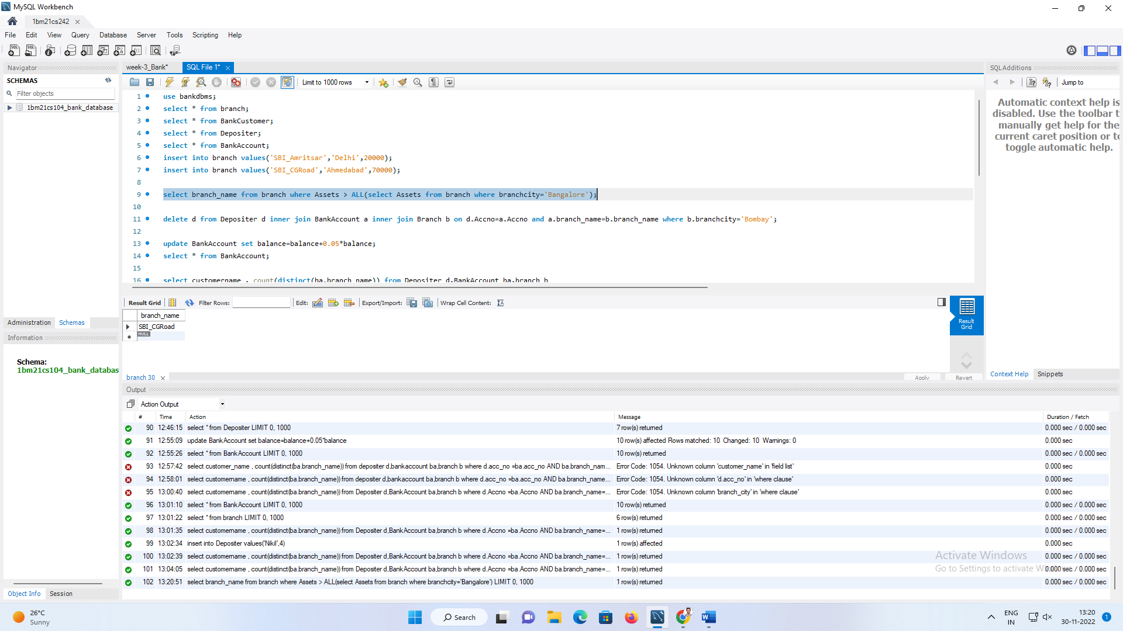select branch_name from branch where Assets > ALL(select Assets from branch where branchcity='Bangalore');

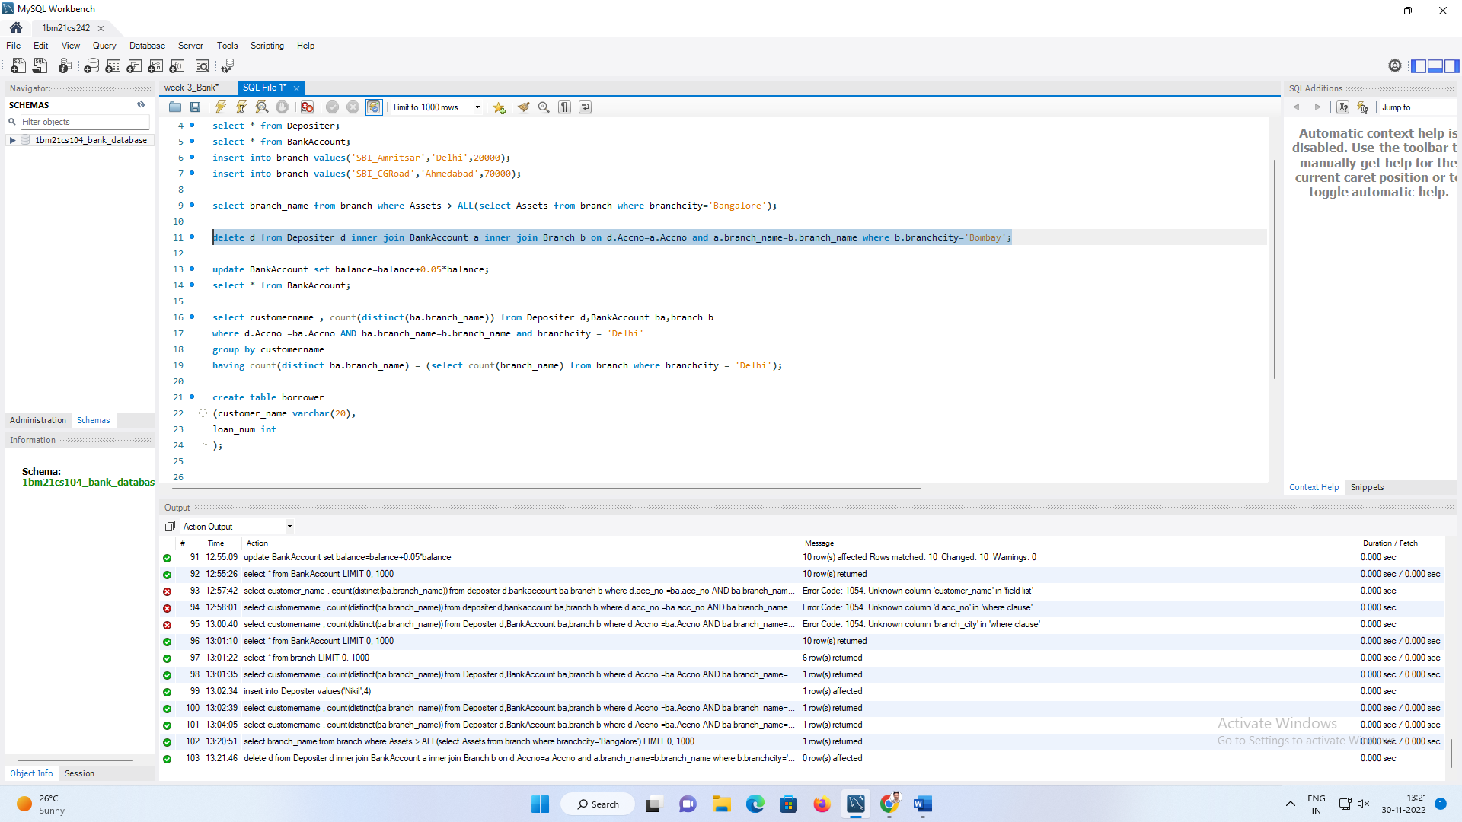5.delete d from Depositer d inner join BankAccount a inner join Branch b on d.Accno=a.Accno and a.branch_name=b.branch_name where b.branchcity='Bombay';

6. update BankAccount set balance=balance+0.05*balance;

select * from BankAccount;

